Comparison Table:

|  |  |  |  |  |  |  |  |  |
| --- | --- | --- | --- | --- | --- | --- | --- | --- |
| **Page No/Index** | **Run** | **Gen Number** | **Best Fitness** | **Avg Fitness** | **Worst Fitness** | **Avg Tree Depth** | **Phenotype** | **Generated XL name** |
| **1** | **1** | 10000 | 0.491189 | 0.491189 | 0.491189 | 3 |  | gpGenerationResult (RUN 1).csv |
| **2** | **2** | 10000 | 0.877078484 | 0.877078484 | 0.877078484 | 6 |  | gpGenerationResult (RUN 2).csv |
| **3** | **3** | 10000 | 0.245594517 | Infinity | Infinity | 5.166666667 |  | gpGenerationResult (RUN 3).csv |
| **4** | 4 | 10000 | 4.71E-16 | 4.71E-16 | 4.71E-16 | 6 | (x*(3-(5-(3+x)))) + (((5+4)+(1/1)+(x+y)-(5+4))) | gpGenerationResult (RUN 4).csv |
| **5** | **5** | 10000 | 0.491189034 | 0.491189034 | 0.491189034 | 3 |  | gpGenerationResult (RUN 5).csv |
| 6 | 6 | 10000 | 3.16E-16 | 3.16E-16 | 3.16E-16 | 5 | [((x-x)-(1-5))+((x*x)-(1-x))] - [((2-x)+(4-4))-y] | gpGenerationResult (RUN 6).csv |
| **7** | **7** | 10000 | 0.491189034 | 0.491189034 | 0.491189034 | 5 |  | gpGenerationResult (RUN 7).csv |
| **8** | **8** | 10000 | 0.712694418 | 0.712694418 | 0.712694418 | 3 |  | gpGenerationResult (RUN 8).csv |
| **9** | **9** | 10000 | 0.487404312 | 0.487404312 | 0.487404312 | 5 |  | gpGenerationResult (RUN 9).csv |
| **10** | **10** | 10000 | 0.352987252 | 0.352987252 | 0.352987252 | 5 |  | gpGenerationResult (RUN 10).csv |
| **11** | Misc Run | 10000 | 1.55E-16 | 1.55E-16 | 1.55E-16 | 5 | [y+(x*(y-x))] + (1+y) |  |

Run 1:  
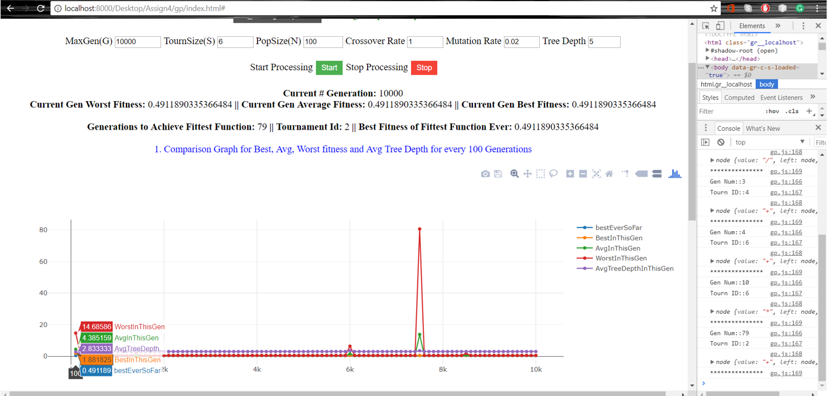

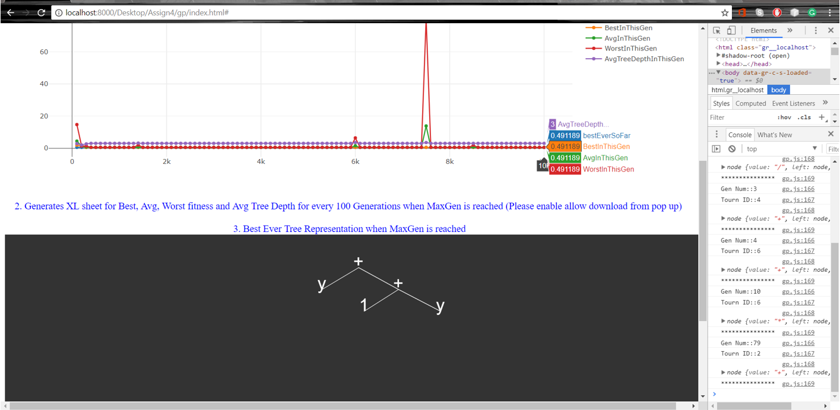

Run 2:  
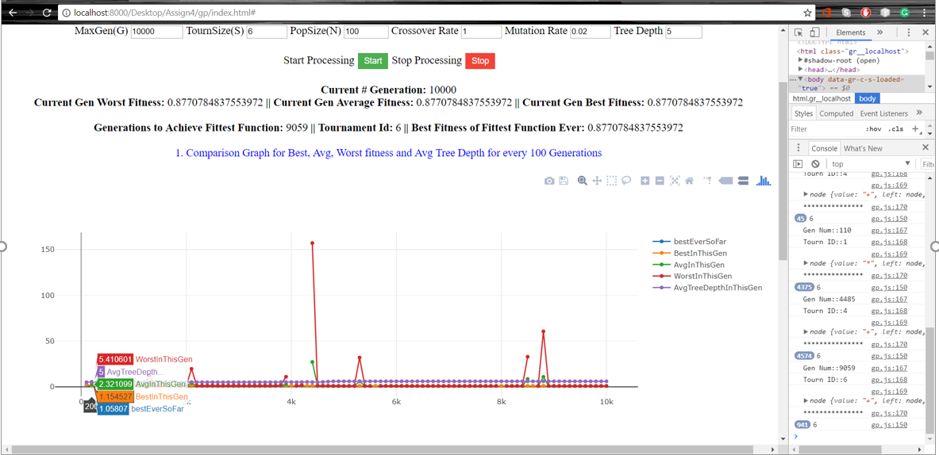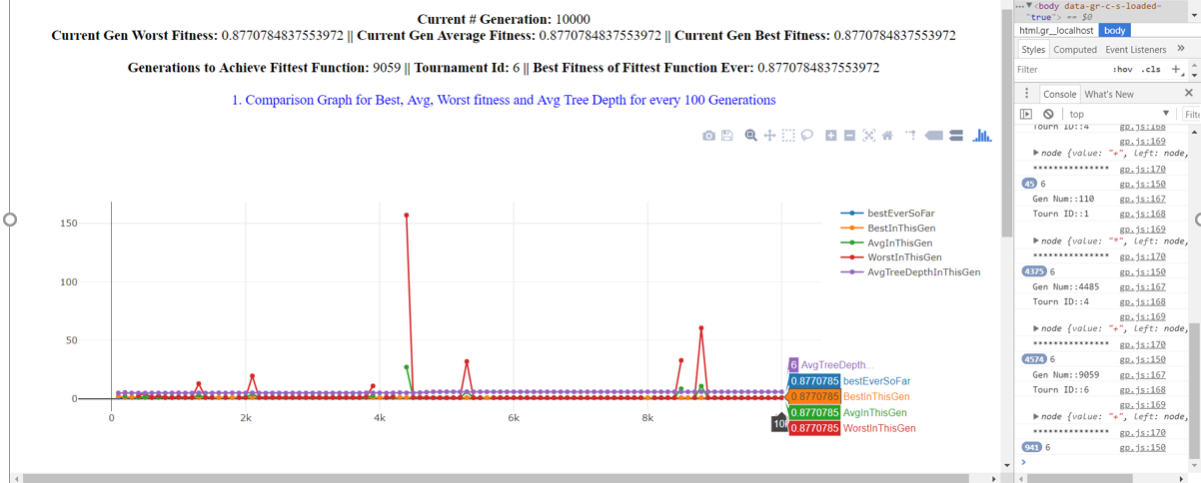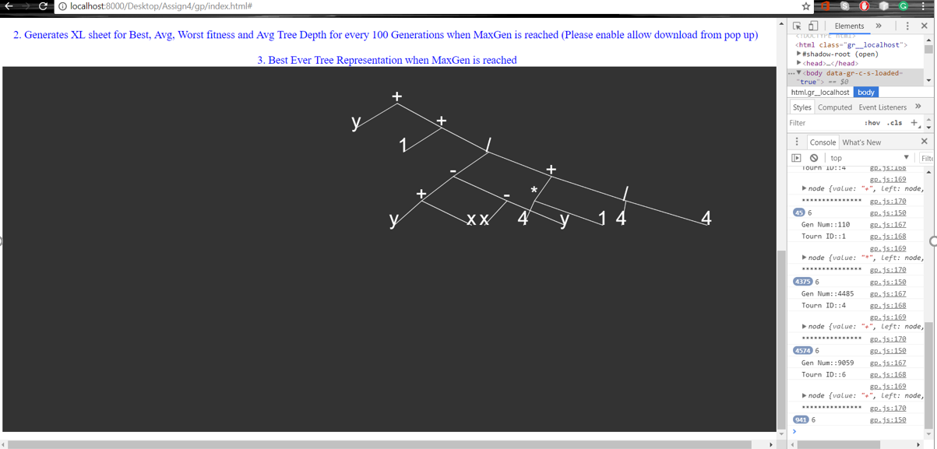  
  
  
  
  
  
  
Run 3:  
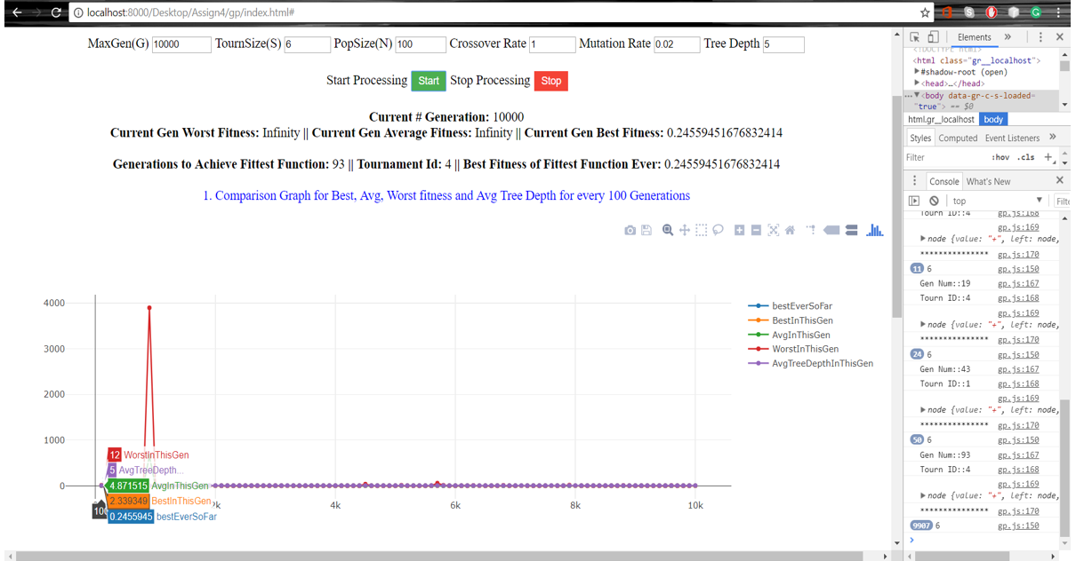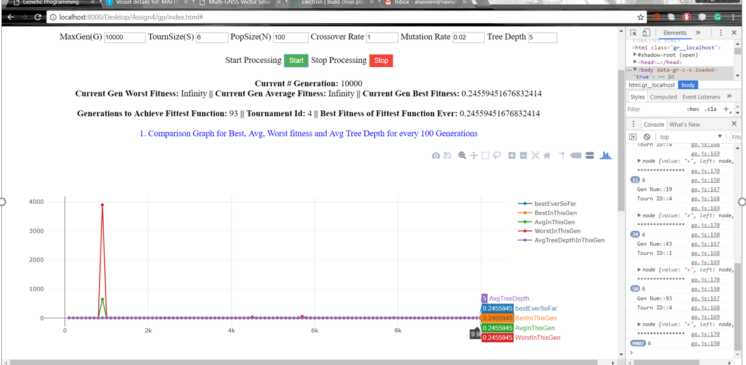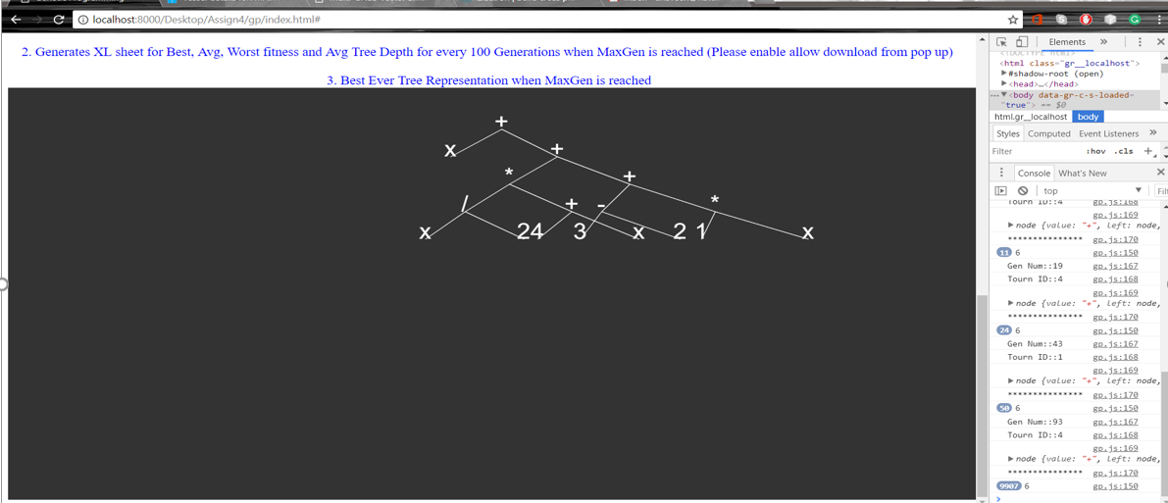

Run 4:  
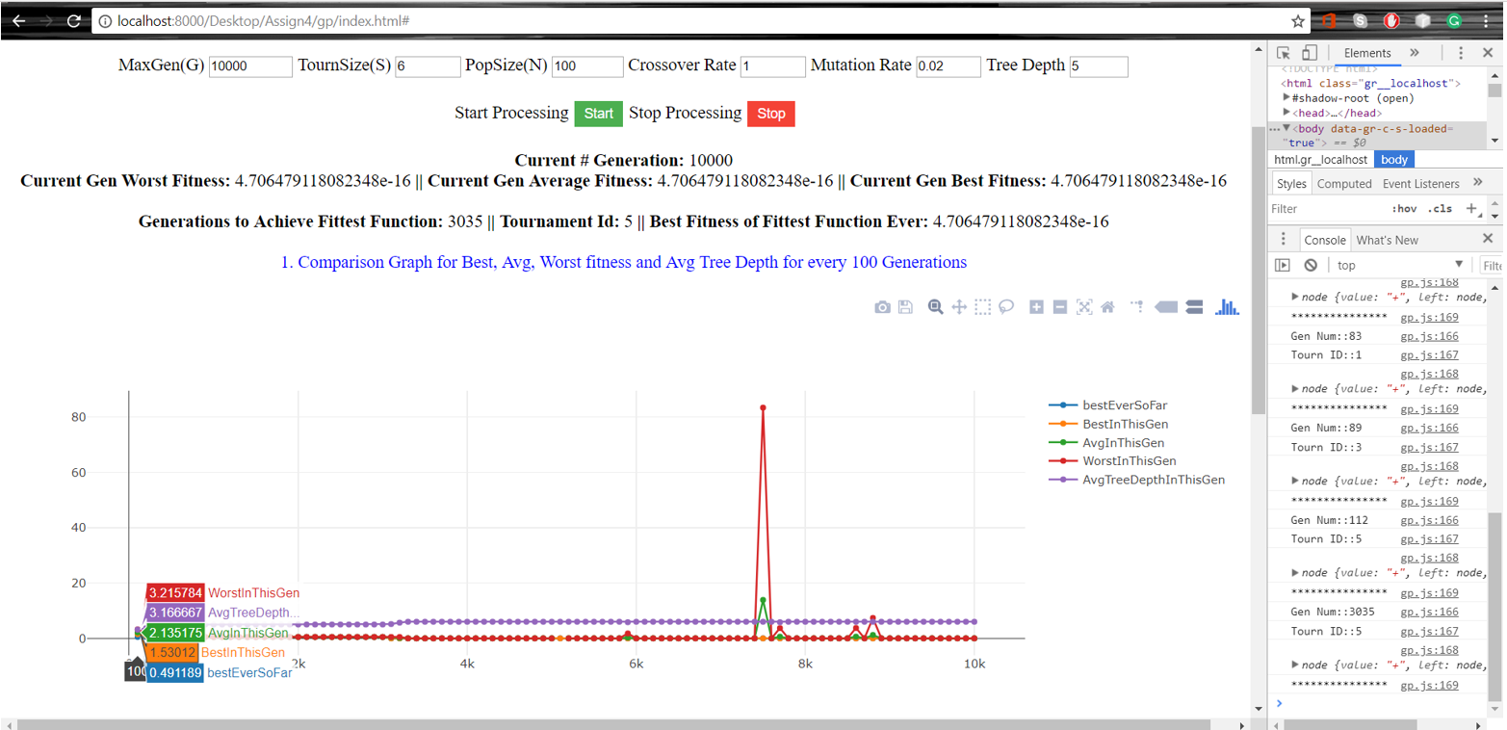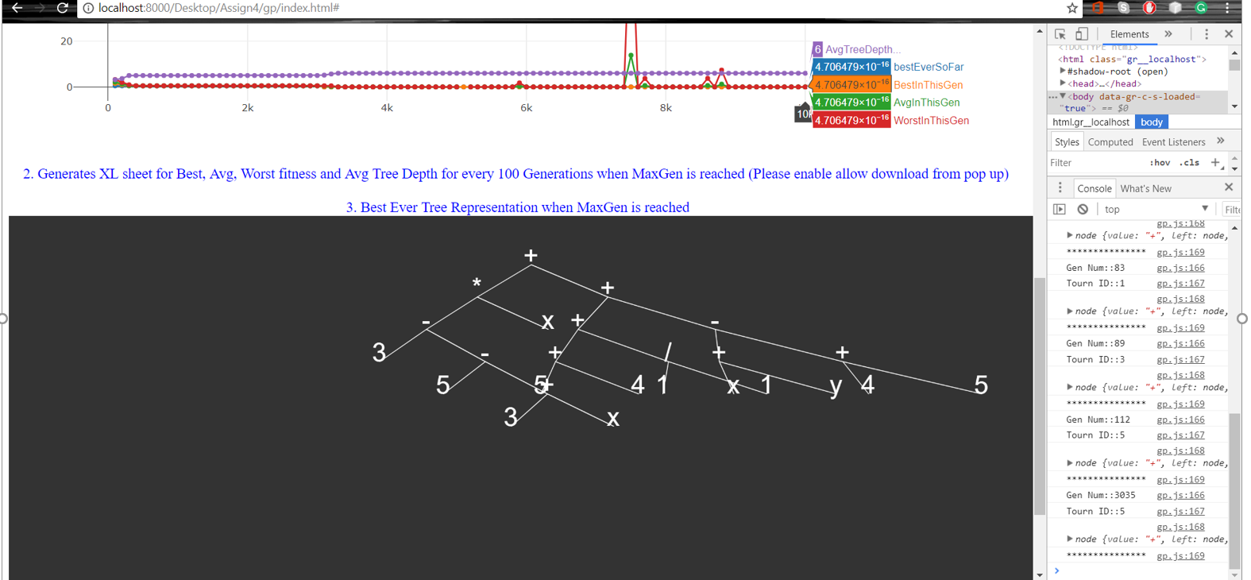

**Phenotype**: (x*(3-(5-(3+x)))) + (((5+4)+(1/1)+(x+y)-(5+4)))

Run 5:  
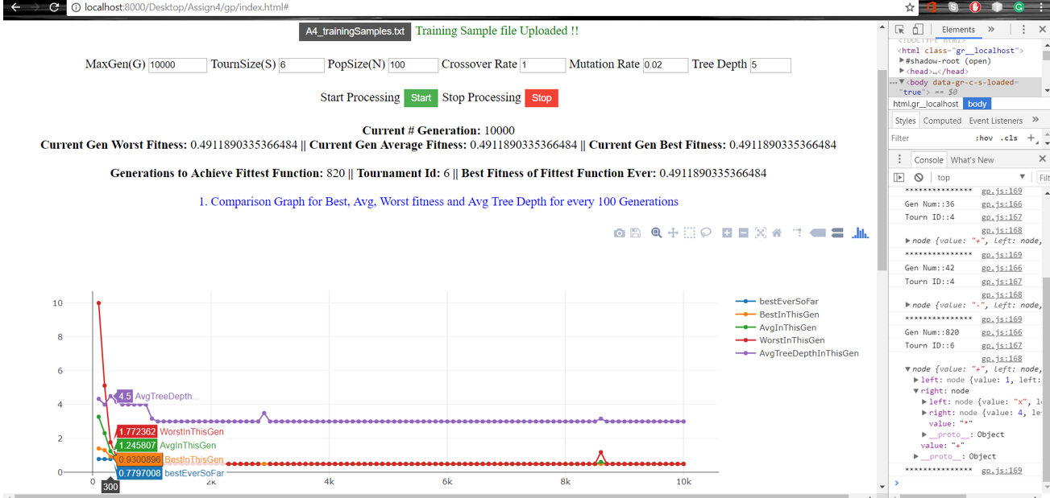

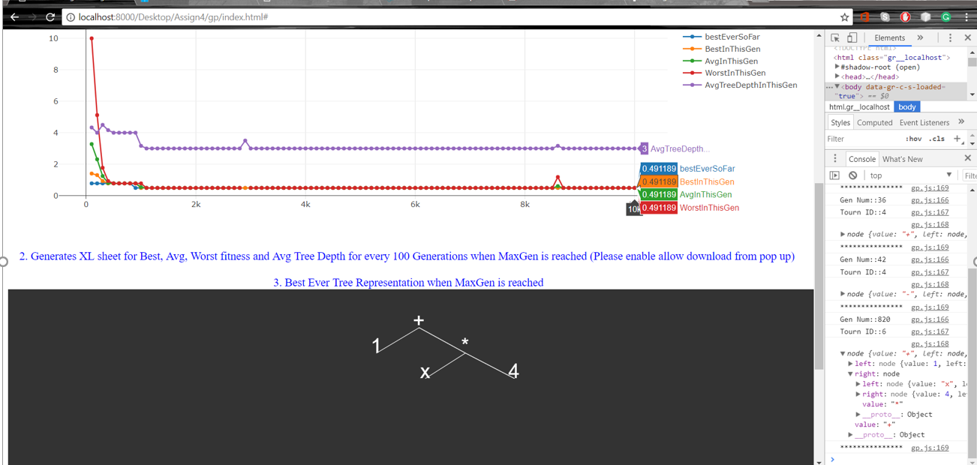

Run 6:  
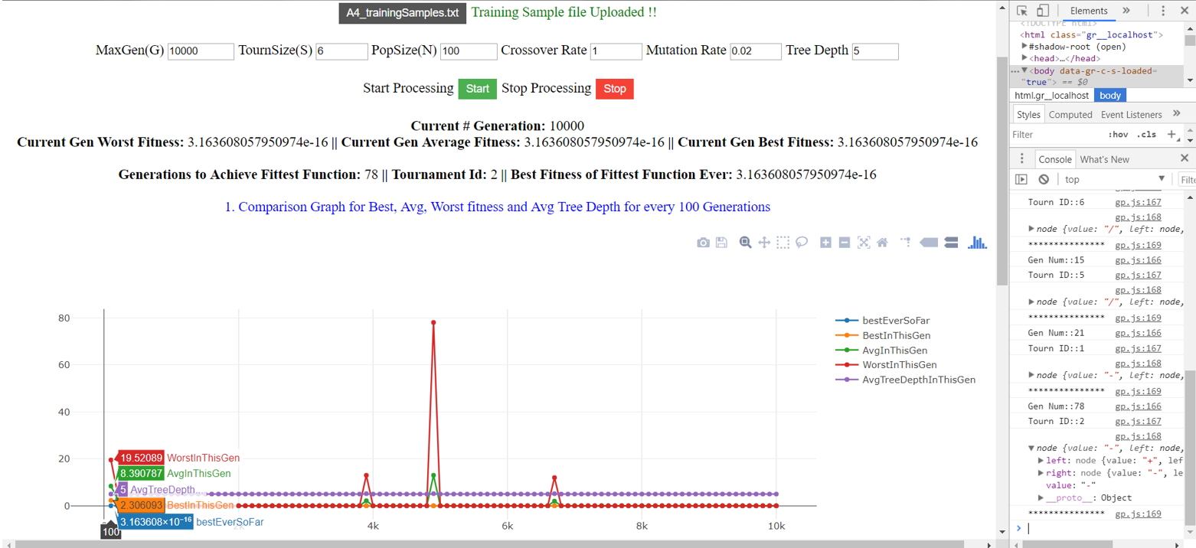

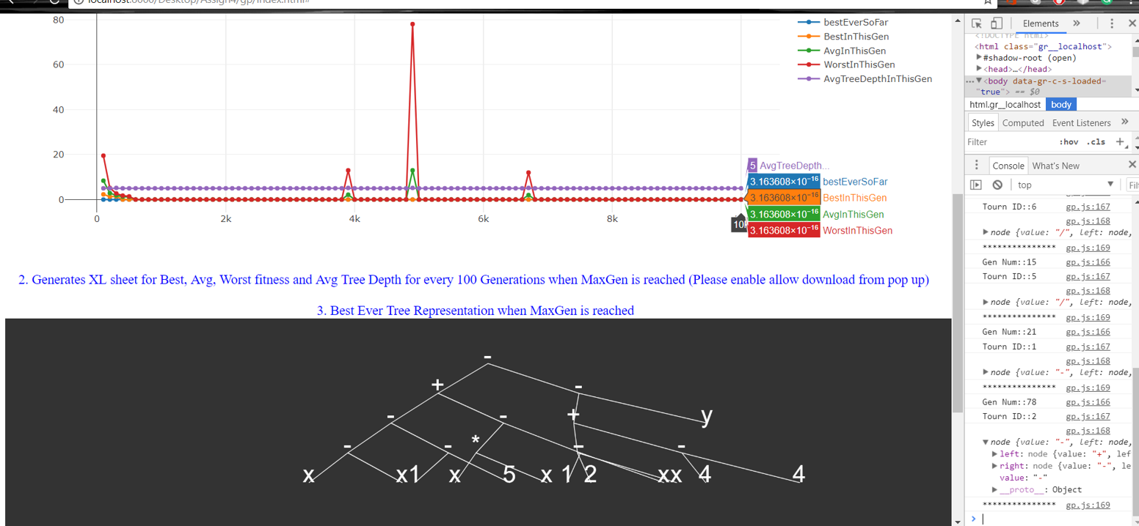

**Phenotype:** [((x-x)-(1-5))+((x*x)-(1-x))] - [((2-x)+(4-4))-y]

Run 7:  
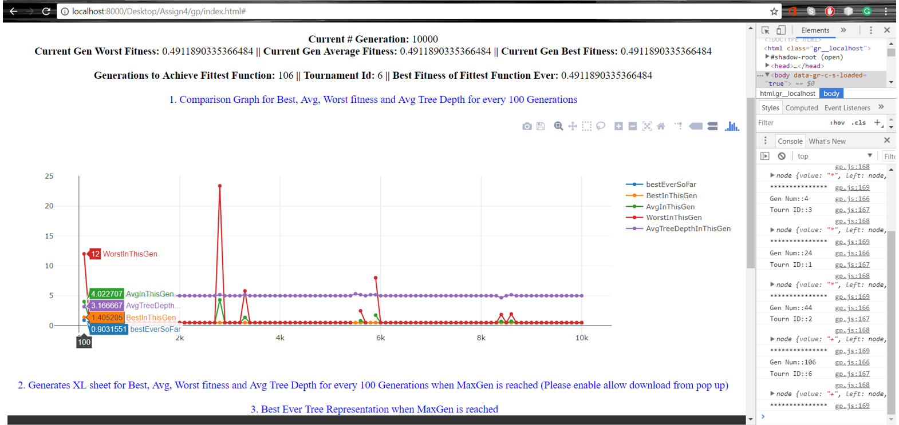 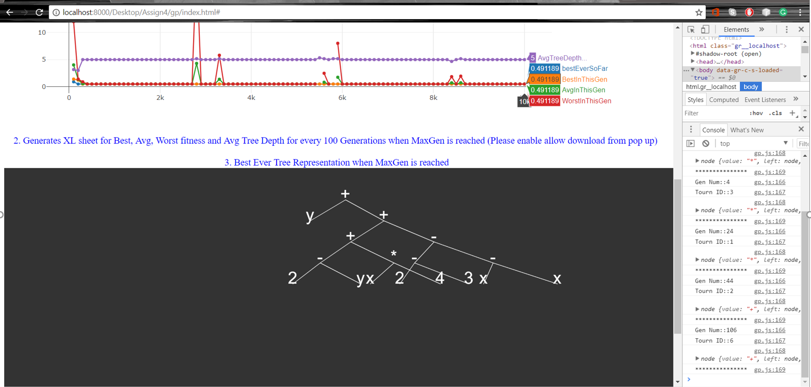

Run 8:  
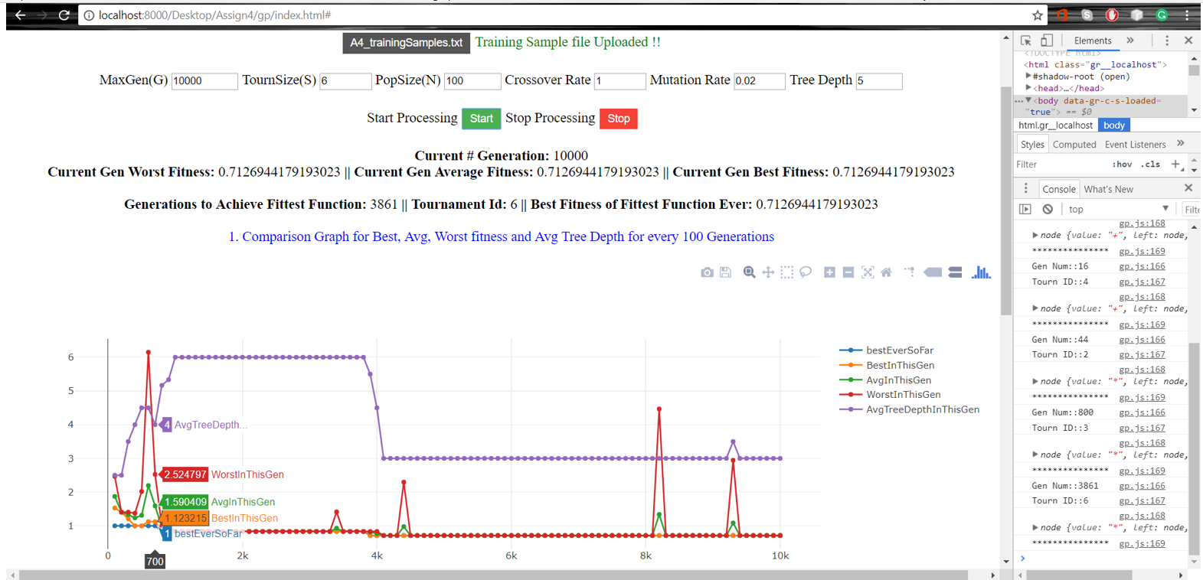 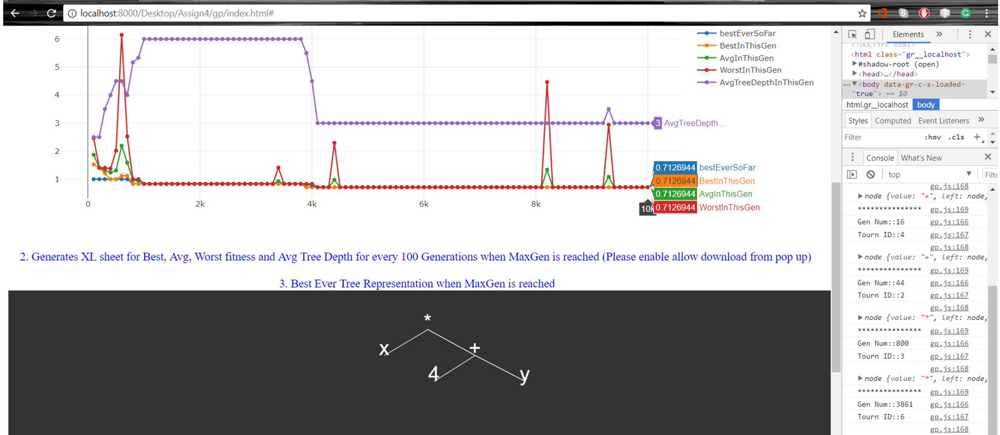

Run 9:

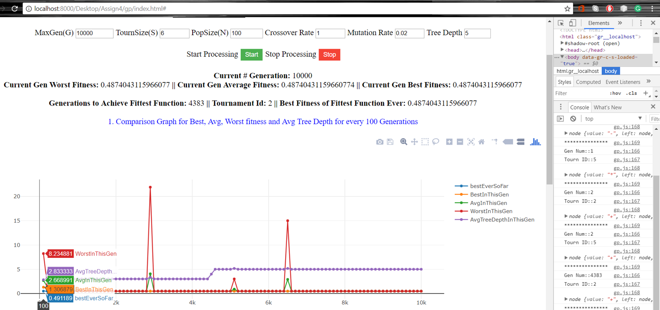 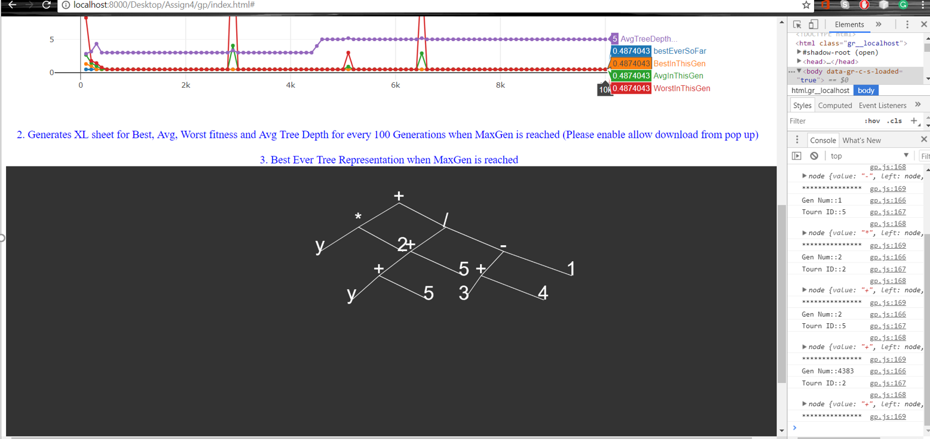

Run 10:  
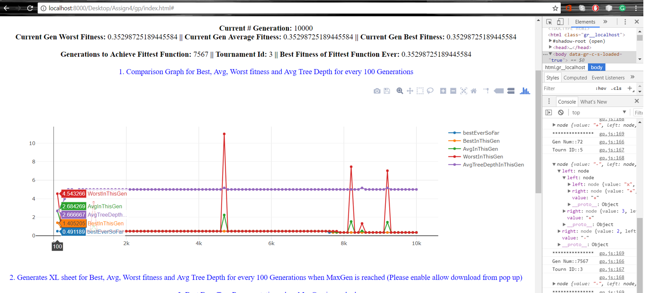

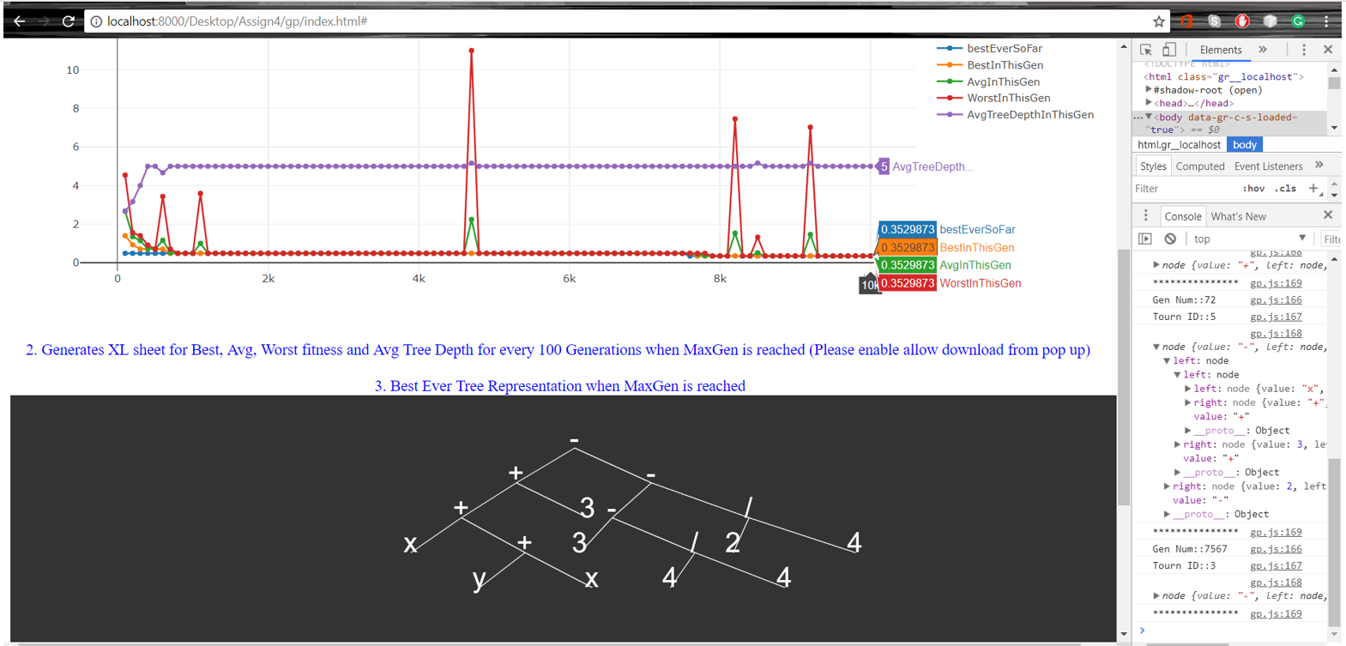

Best Run Random:

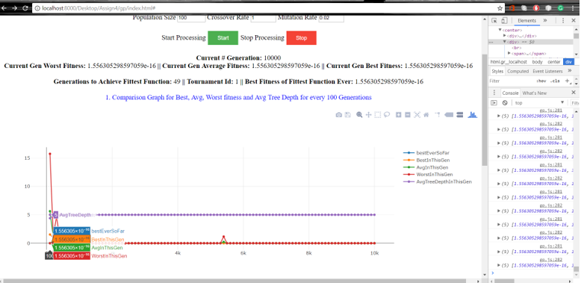

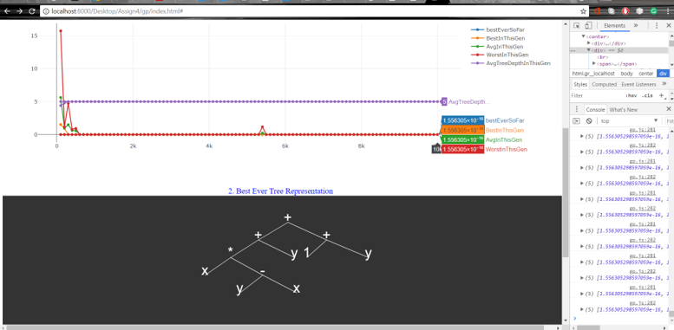

**Phenotype:** (y+(x*(y-x))) + (1+y)